## Mean Absolute Error

* Imagine your friend has the below cards in his hand and asks you to make random guesses to predict the cards in his hand:
* 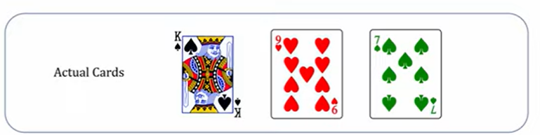
* And you will make random guesses and predict the below listed 3 cards:
* 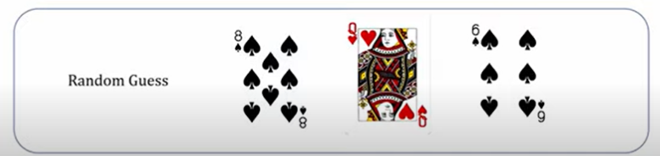
* An you ask your friend about how accurately you made the prediction
* One way to find the error is getting absolute distance i.,e find the distance between the King card and card number 8 which is 5 (9, 10, jack, queen, king)
* 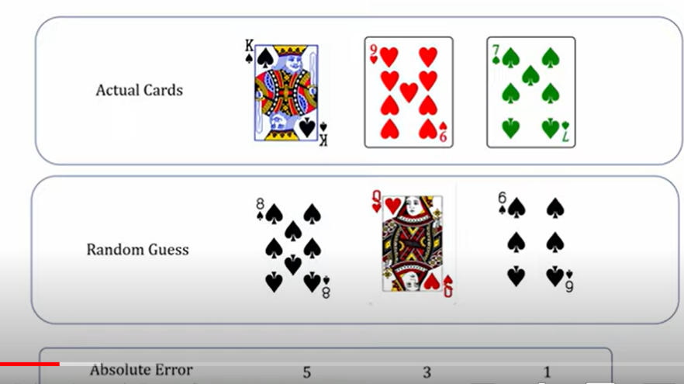
* Therefor, mean absolute error for the above predictions of card is = (5 + 3 + 1) / 3 = 9/3 = 3

## Mean Squared Error

* Here, the squares of the error is taken and then the average of the squared error value is calculated
* 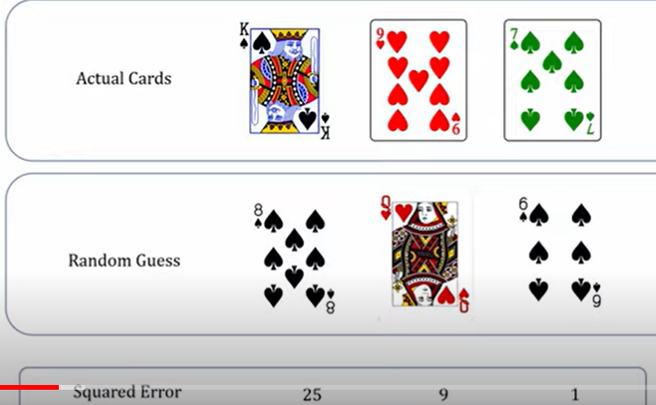
* Therefore, mean squared error = (25 + 9 + 1) / 3 = 35 / 3
* ***Note: Having squared error helps gradient descent to converge in a better way***

## Why is the loss or cost function used in neural networks?

* 
* 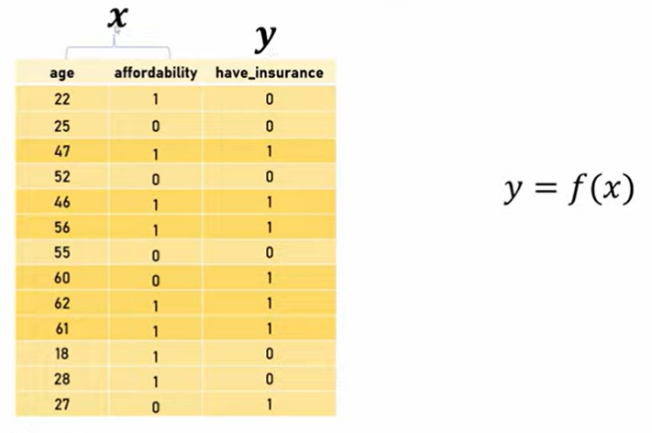
* In ML/DL our aim is to come up with a function f(x) to predict the ‘y’ value
* 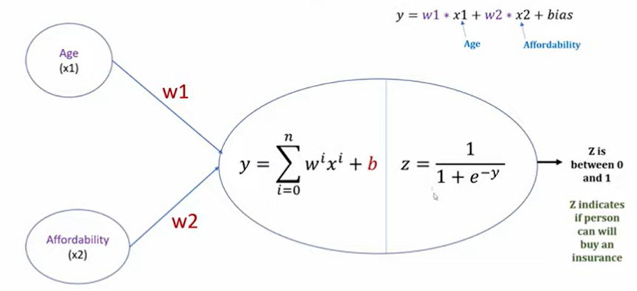
* So, here we need to find the weights w1 and w2
* And we find the value of w1 and w2 through trial and error method
* So, first we initialize the value of w1 and w2 as 1 which is shown in the below image
* 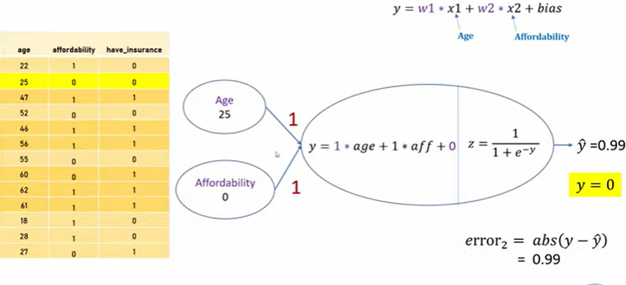
* The above image shows the error calculation that is done for 2nd instance in the sample data
* So, we will calculate the error for all the other instance and then we find the mean absolute error for all the errors of 13 instances in the sample data
* 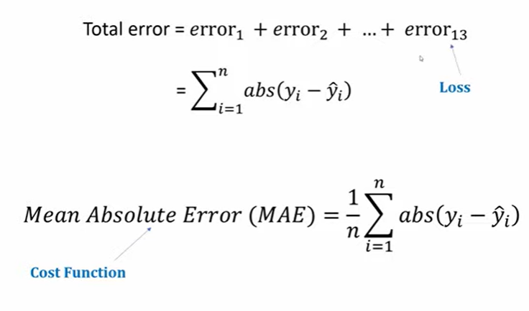
* In the above image, each individual error that is calculated is called ***loss*** and mean absolute error is called as ***cost function***
* One round of forward passing or calculating the cost function by iterating through all the data instance in training data set is called ***1 epoch***
* 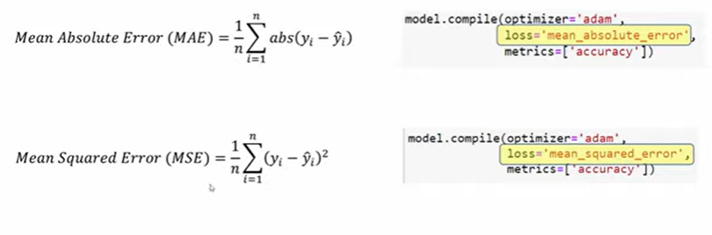

## Log Loss Function

* 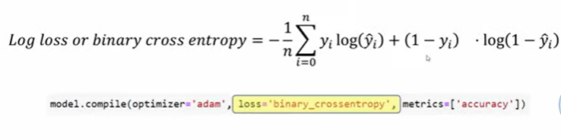
* For logistic regression, we use log loss as loss function
* Why do we use log loss for logistic regression? - learn from towards data science website